March 6, 2024

Dear Business Owner:

Ulster County’s Summer Youth Employment Program helps young people from low-income households gain valuable work experience and a significant wage. By connecting youth ages 14-20 to jobs, we support them in acquiring the skills, habits and values needed to become a vital part of Ulster County’s emerging workforce and encourage them to stay in Ulster County as working adults.

We are looking for worksites to employ our participants from July 1st through August 2nd. Our young adults are paid fifteen dollars an hour ($15.00) and are eligible to work up to 40 hours a week. All wages and taxes are paid by Ulster County.

If you’ve been a worksite before, thank you! We look forward to working with you again.

If you have not participated, we hope this is the year you choose to do so. Worksites play a critical role in our participants’ success by providing strong supervision and mentoring that helps young people develop the habits and soft skills necessary to be successful in a work environment. Site supervisors are the key to our program’s success.

All worksites and supervisors are required to attend an online, one-hour Worksite Orientation Session. Those worksite supervisors who attended orientation in 2021, 2022, or 2023 are EXEMPT from this requirement.

To become a worksite for 2024, please complete the enclosed form. If you have questions, please contact Janet Rigaux at: jrig@co.ulster.ny.us or 845-340-3173. We look forward to working with you this summer.
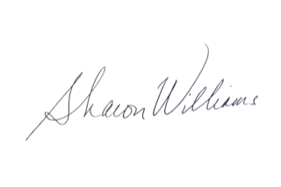
Sincerely,

Sharon Williams, Director
Ulster County Office of Employment & Training
Ulster County Workforce Development Board

